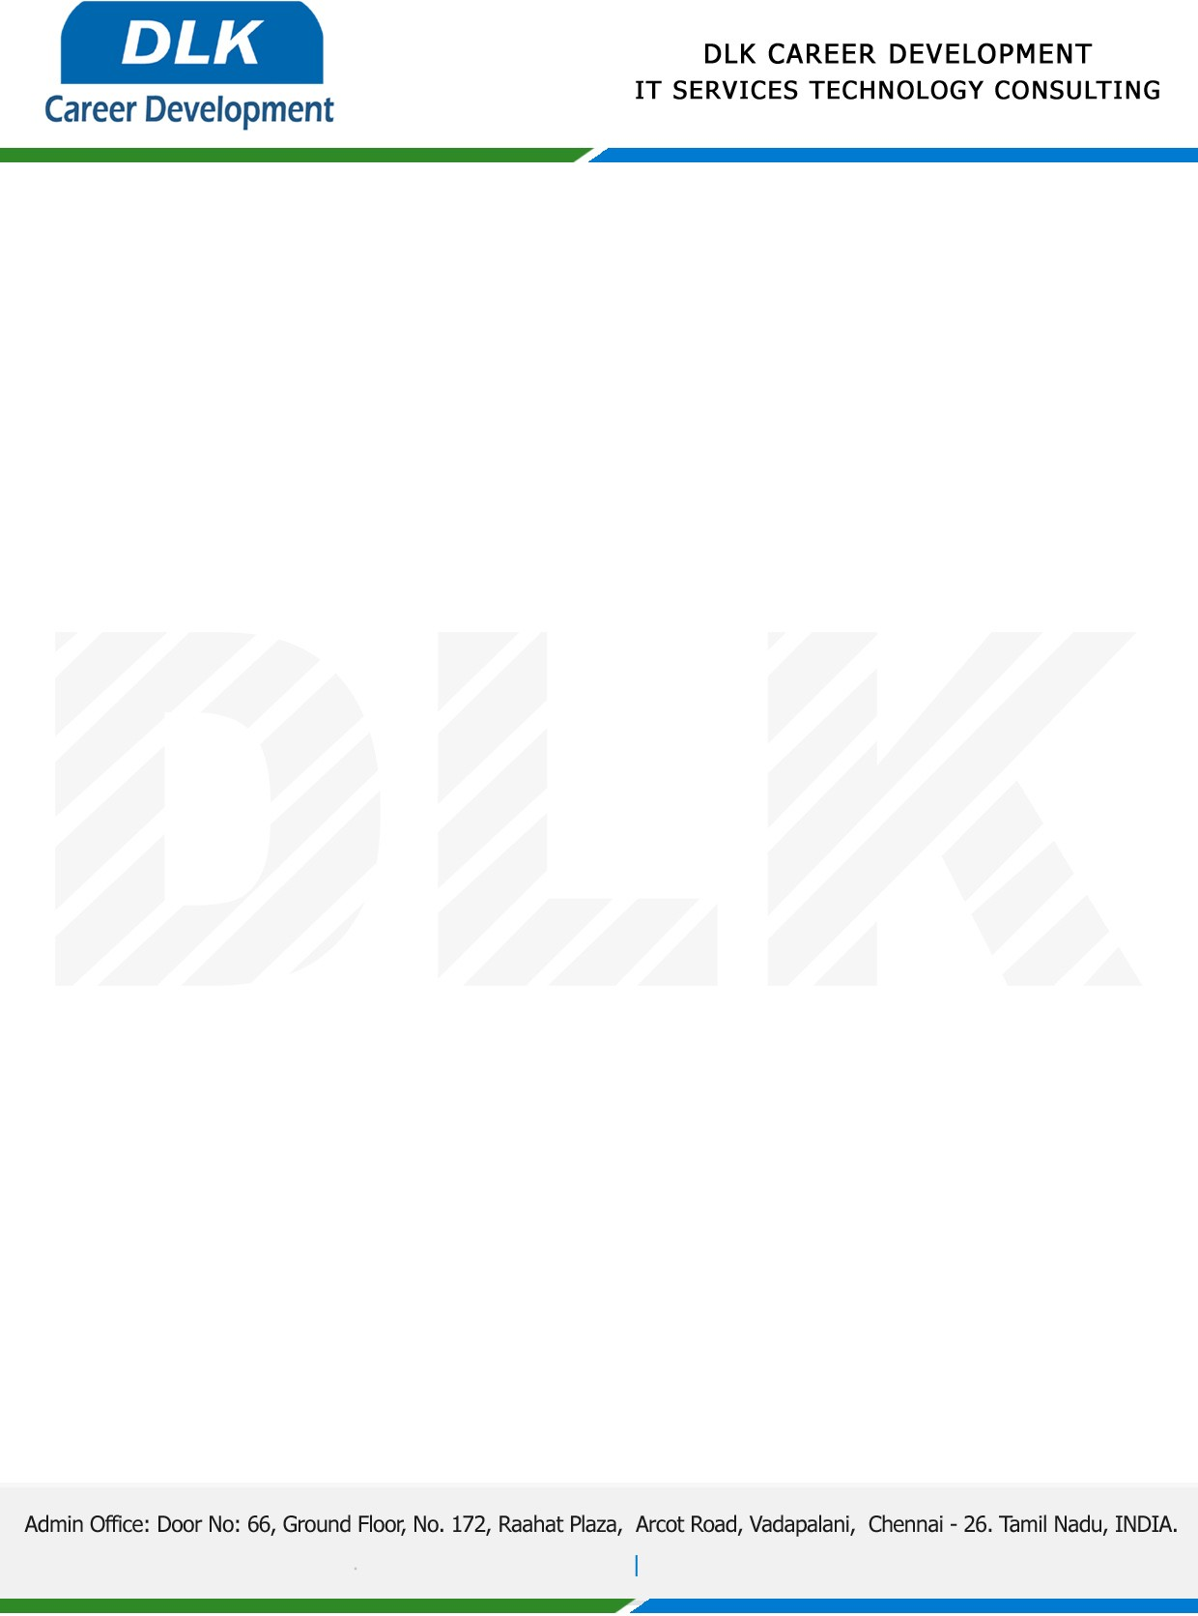

**Date: 29/April/ 2023**

**COURSE COMPLETION CERTIFICATE**

**Name:** MR DILIP ANTONY L

**Reference Number:** 253113577933

**College Name**:Sathyabama Institute of Science and Technology, Chennai.

**Degree & Department:** B.E (Computer Science and Engineering)

**Batch ID:** 2020 – 2024

**Program language:** Core & Advanced Java

*{ Basic of Java, OOPS, Array, Control Statement, Exception Handling, Multithread*

*Collections, JDBC, MYSQL, HTML, CSS, JavaScript}*

**Duration:** January 2023and February 2023 **(2 Months)**

**MR DILIP ANTONY L ,** displayed professional traits during the Course period and managed to complete all assigned tasks as required. He was Hardworking, dedicated and committed it was a pleasure with us in this short period.

**We** **Wish all the best for your future.**

For **DLK CAREER DEVELOPMENT**

**HR Manager**

**VELMURUGAN J**